Theories about the Changing Face of the Earth

The Earth’s features are not fixed and are always changing. It takes thousands or millions of years before a considerable amount of change happen. But there are also certain events that may cause a sudden change of the Earth’s surface.

There are three theories that describe how the location of the continents shifted from their original position to where they are today. These theories are:

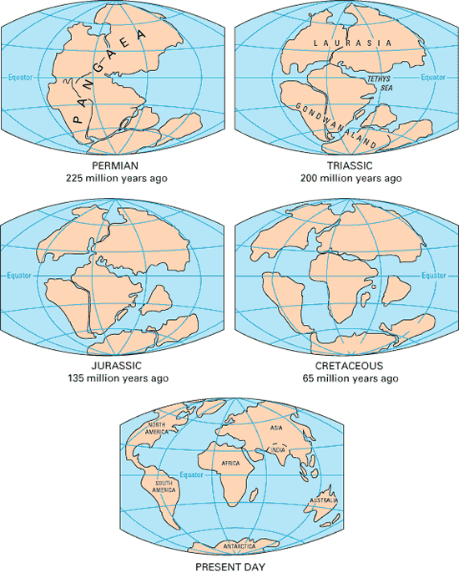
- Continental Drift Theory

The Continental Drift Theory (by Alfred Wegener) states that all of the world’s land masses were originally joined as one large continent called Pagea and that it broke and drifted apart over millions of years. This theory of his is based on the observations he made on the fossil of a plant named Glossopteris. He found that this fossil can be found on different parts of the world and they were all far from each other. Another basis for his theory is that some continents have matching coastlines and the many similarities of the continents with each other. He deduced that this was only possible if all the land masses were at some point connected with each other.

It is believed that Pangea started to break apart approximately 200 million years ago. The large fragments became the continents and moved slowly, for millions of years to their current position today. The movement of the continents is called Continental Drift, thus the name of the theory.

*Note: Look at a world map. Notice that the continents look like pieces of a jigsaw puzzle and if you cut out the individual pieces, you can connect them with one another.

- Ocean Floor Spreading Theory

This theory states that the ocean floor is spreading or moving at a slow rate. This is caused primarily by the magma that is pushing upward on the center of the ridges or Ocean Mountains. As the lava reaches the surface, it forces the older rocks to move away to either side.

*Note: This can be tied up with the Continental Drift Theory. The movement of the continents is the result of the spreading/movement of the ocean floor.

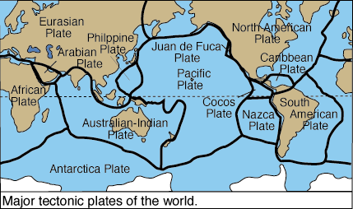
- Tectonic Plates Theory

The Earth’s crust is not a single piece of solid material. It is broken up into slabs or pieces called plates. These plates move as molten rock rises from the Earth’s core. The cooler and denser rocks sink while the hotter and less dense rocks rise. As they rise to the surface, these convection currents (Convection occurs because the density of a fluid is related to its temperature) carry the continents with them.

