Hydrosphere

Overview

Discontinuous layer of water at or near the Earth’s surface.

It includes all liquid and frozen surface waters, groundwater held in soil and rock, and atmospheric water vapour. Virtually all of these waters are in constant circulation through the hydrologic cycle. Although the components of the hydrosphere are undergoing continuous change of state and location, the total water budget remains in balance. The components of the hydrosphere have been seriously affected by the water-polluting activities of modern society.
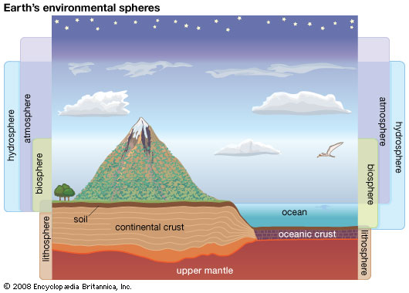

Main

Water is the most abundant substance at the surface of the Earth. About 1.4 billion cubic kilometres (326 million cubic miles) of water in liquid and frozen form make up the oceans, lakes, streams, glaciers, and groundwaters found there. It is this enormous volume of water, in its various manifestations, that forms the discontinuous layer, enclosing much of the terrestrial surface, known as the hydrosphere.

Central to any discussion of the hydrosphere is the concept of the hydrologic cycle. This cycle consists of a group of reservoirs containing water, the processes by which water is transferred from one reservoir to another (or transformed from one state to another), and the rates of transfer associated with such processes. These transfer paths penetrate the entire hydrosphere, extending upward to about 15 kilometres (nine miles) in the Earth’s atmosphere and downward to depths on the order of five kilometres in its crust.

Distribution and quantity of the Earth’s waters
Ocean waters and waters trapped in the pore spaces of sediments make up most of the present-day hydrosphere (see Table 1). The total mass of water in the oceans equals about 50 percent of the mass of sedimentary rocks now in existence and about 5 percent of the mass of the Earth’s crust as a whole. Deep and shallow groundwaters constitute a small percentage of the total water locked in the pores of sedimentary rocks—on the order of 3 to 15 percent. The amount of water in the atmosphere at any one time is trivial, equivalent to 0.013 × 106 cubic kilometres of liquid water, or about 0.001 percent of the total at the Earth’s surface. This water, however, plays an important role in the water cycle.
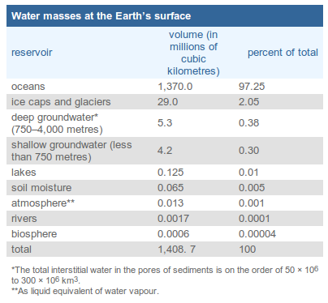

At present, ice locks up a little more than 1 percent of the Earth’s water and may have accounted for as much as 3 percent or more during the height of the glaciations of the Pleistocene epoch (from 1,600,000 to 10,000 years ago). Although water storage in rivers, lakes, and the atmosphere is small, the rate of water circulation through the rain–river–ocean–atmosphere system is relatively rapid. The amount of water discharged each year into the oceans from the land is approximately equal to the total mass of water stored at any instant in rivers and lakes.

Soil moisture accounts for only 0.005 percent of the water at the Earth’s surface. It is this small amount of water, however, that exerts the most direct influence on evaporation from soils. The biosphere, though primarily H2O in composition, contains very little of the total water at the terrestrial surface, only about 0.00004 percent. Yet, the biosphere plays a major role in the transport of water vapour back into the atmosphere by the process of transpiration.

As will be seen in the next section, the Earth’s waters are not pure H2O but contain dissolved and particulate materials. Thus, the masses of water at the Earth’s surface are major receptacles of inorganic and organic substances, and water movement plays a dominant role in the transportation of these substances about the planet’s surface.

